SMALL HYDRO POWER DEVELOPERS ASSOCIATION
Regd No.114/2002
6-3-347/17/5, DWARAKAPURI COLONY, PUNJAGUTTA, HYDERABAD.
Phone No. 9848153580, 040-23354404, Email: smallhpda@yahoo.co.in

To
The Secretary,
Secretary, APERC,
11-4-660, 4th Floor,
Singareni Bhavan, Red Hills,
Hyderabad –500 004

To
The Chief General Manager (RAC & IPC),
19-13-65/A, Vidyut Nilayam, APSPDCL,
Srinivasapuram,
Tirupathi – 517503

Sir/Madam,
Sub: APSPDCL - Comments/Objections on the ARR & Tariff Proposals for Distribution and Retail Supply Business for the 5th Control Period for FY 2024-25 to 2028-29 - Determination of Distribution tariff.
Ref: Public Notice in O.P. No. 74 of 2023, dated 10-12-2023.
* * *
With reference to the Public Notice calling for Views/Objections/Suggestions, we would like to submit the following objections/suggestions.
Need to Determine Energy Based Transmission & distribution Charges:

1). The PLF of Mini-Hydel Power Plant is varies from 10% to around 35% in Andhra Pradesh depending on the water availability. In our submissions, we have considered a PLF of 20% for Mini-Hydel power plants as we come across drought situation/conditions during certain years. For example, during 2001-02 to 2003-04 we had to face severe drought conditions.

The mini hydel power developers attracted by the Central/ State Government policies several entrepreneurs have ventured into mini hydel power generation and established around 70 MW generation capacity in Andhra Pradesh. Almost all the existing generating stations have come into generation late 1990s and early 2000 years.

In the years 2001-02, 2002-03 and 2003-04 years being drought years there was absolutely minimal or no power generation. In those days the interest rates were around 17% which was very high. The drought conditions for 3 long consecutive years has resulted in loans increasing by 150%. We were forced to get the loan repayment period rescheduled from 8 years to 20 years. All the power developers purchase and wheeling agreements period with AP transco and discoms were over by 2019 and 2020 years. Presently, all the mini hydel stations are now in open access system.

2). So far, the Hon’ble Commission has determined the Transmission & Distribution Tariff based on capacity to be Wheeled or transmitted. The wheeling charges and transmission charges were fixed on the contracted capacity by APERC in the MYT Order for 2019-24. Though Hon’ble Commission (APERC) has fixed the Wheeling/Transmission charges on contracted capacity, the implementing agencies DISCOMs have collected it on installed capacities for some of the developers neglecting representations made by us.

Now this year being a drought year and the reservoirs are empty no water is being released into the irrigation canals, which has resulted in absolutely zero generation. But still the wheeling charges are being paid since it is levied on contracted capacity. For the reasons mentioned above, we request the Hon’ble Commission to fix the wheeling charges based on the delivered Energy (Energy pumped into the grid) instead of on contracted capacity.

3). The Open Access Demand permitted to a Consumer is allowed within the CMD of a consumer. The demand charge of Rs 475/kVA/month is determined considering diversity factor of 60% to 70%. The Demand charge consists of fixed costs of Generation, Transmission and Distribution business. The same can be seen in the RST of 2017-18 or previous Tariff Orders. Presently, no Demand Charges are being determined and the Demand Tariff determined in the year 2017-18 is being continued. This means, already the transmission and distribution business costs are built in the RST tariff and are being recovered in the form of MD charges.
The RST ARR of APSPDCL is furnished below.

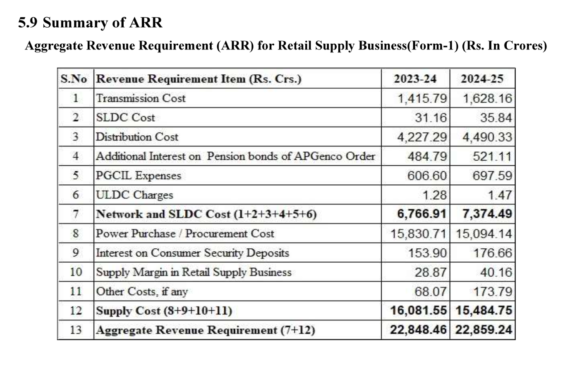

4). Levy of Distribution tariff & Transmission tariff based on capacity contracted may not be a correct approach and is not just especially for Mini-Hydel power plants for which PLF is around 20%. The DISCOM is allowing OA/Wheeling capacity within the CMD and the Consumer pays MD charges as per the terms and conditions of tariff. The Hon’ble Commission may please consider levy of reasonable energy based Transmission/Distribution charges for the reasons mentioned below.
Mini-Hydel Power generation is seasonal and not in the hands of Generator. The release of water is regulated by irrigation department based on the crop pattern and need of the farmers and hence the power generation is not continuous.
Whenever the MINI-Hydel Power is not available, the OA/Wheeling consumer will come back on to the DISCOM power as the consumer has CMD with the DISCOM and draws required power from the DISCOM. Thus, the DISCOM recovers its fixed cost in the form of MD charge. This indicates that the consumer always draws his required Demand within the CMD from the grid; be it may from the DISCOM or from the OA Generator/Exchange. In the absence of Mini-Hydel power, the short fall power required is drawn from the DISCOM and thus always uses the network to the extent of Contracted Capacity and pays the fixed cost related to Transmission and business as per the Tariff Order.

As the consumer draws the power from the DISCOM in the absence of power from Renewable Energy (RE) source due to its inherent nature, the network capacity is fully utilised and hence there is no loss to DISCOM/APTRANSCO. The OA/Wheeling Consumer apart from paying fixed cost, he also pays the Transmission/Wheeling charges.
This means, already the transmission and distribution business costs are built in the Retail tariff and are being recovered in the form of MD charges from a consumer who is availing power through Open Access. The DISCOM is receiving transmission fixed costs built in the demand charges and APTRANSCO is levying transmission charges. It amounts to levying two charges for providing one service, viz., one is in the form of Demand Charge and the other one is in the form of Transmission/Wheeling charge.

In this regard, we submit to determine nominal energy-based Distribution Charges instead of capacity-based wheeling charges.

5). As per the formula specified by the Hon’ble Commission in the APERC (Terms & Conditions for determination of Tariff for transmission of electricity) Regulation No. 1 of 2019 (First Amendment to Regulation No. 5 of 2005), the Transmission tariff (rate) proposed for FY 2024-25 is Rs. 221.17/kW/Month and the DISCMs would pay the ARR of APTRANSCO based on their Contracted Capacity and would be taken into DISCOMs ARR to arrive at the Retail tariff. The same is mentioned in Para 3 above. Please see Row 1 and Row 3 in Para 3 above wherein the ARR of 1415.79 crs of APTRANSCO and 4227.29 crs of Distribution Business are mentioned respectively.
The Transmission ARR and distribution ARR determined would be built into the DISCOM’s ARR. While determining the Retail Supply Tariffs (RST), the transmission ARR & distribution ARR would be distributed across all voltages and all category of consumers and RST is determined. The Transmission ARR/network cost is not apportioned to voltage wise based on Demand consumption of 132 kV consumers, 33 kV consumers, 11 kV consumers and LT consumers while determining the distribution charges.
To determine the distribution wheeling charges, the Distribution ARR is apportioned (allocated) to 33 kV, 11kV, and LT voltages based on demand consumption. To arrive at the Demand on the 33 kV system, the LT and 11 kV demands are grossed up with relevant losses. The Grossing up method is explained in the ARR filed by DISCOMs and is discussed/noted below in para 13.

6). Levy of Capacity based Transmission or Distribution tariff on NCE sources like, Solar, Wind and especially Mini Hydel power plants for which the PLF is around 20% to 35%, amounts to levy of 4 to 5 times of conventional power plant tariff with reference to energy based tariff.

The relevant calculations in support of the above are furnished below.

One kW conventional power plant generator can generate 720 units in a month and thus can pump 720 units into the grid. Whereas a Mini-Hydel power Plant of 1 kW capacity can generate 144 units in a month against the same 1 kW capacity as the PLF of SPP is around 20% only.

The transmission tariff proposed in the MYT ARR for the year 2024-25 is - Rs. 221.17/kW/Month. The per unit transmission charge --- 221.17/720 = Rs. 0.31/kWh for conventional plant.
The per unit transmission charge for Hydel Power Plant --- 221.17/144 = Rs. 1.54/kWh which is 5 times of cost paid by conventional powerplant generator.

For the reasons mentioned above, we submit to levy nominal energy-based Transmission/wheeling charge, instead of capacity based wheeling charge.

7). To determine the wheeling tariff, no methodology is determined by the commission as specified for EHT vide Regulation. 1 of 2019. The Commission has devised its own method and the method followed by the Commission is explained below.
The 33 kV ARR is determined as per the 33 kV network cost. The 33 kV ARR is split into three parts - viz.,
--- ARR in proportion to 33 kV consumer demand would be allocated to 33 kV system.
--- ARR in proportion to 33 kV demand reflecting on 33 kV level from 11 kV consumers would be allocated to 11 kV system.
--- ARR in proportion to 33 kV demand reflecting at 33 kV level from LT consumers demand would be allocated to LT system.
There exist 33 kV, 11 kV and LT Agricultural Lift Irrigation Service owned by Irrigation Department, Panchayatraj and Cooperative Societies. The Cost of Service determined by the Hon’ble Commission is being paid by respective consumers. These Lift irrigation scheme consumers never buy power through Open Access. In this regard, we submit to the Hon’ble Commission to exclude the network cost related LI Schemes while determining the Open Access charges.

8) The Commission has adopted different methods for determining EHT Transmission charges and Distribution charges viz, 33 kV, 11 kV and LT network wheeling charges. It seems this approach may have to be rectified.
If the same principle as mentioned in Para 7 above is followed, we may have to allocate or pass on the EHT network ARR cost (by deducting pro-rata cost in proportion to Demand from EHT consumers) to 33 kV network in proportion to 33 kV demand reflecting on the EHT network from 33 kV consumers and so on to 11 kV and LT network. If it is done, the 33 kV, 11 kV and LT ARR would increase to abnormal level, and this would not reflect realistic tariff. But the ARR pertains to EHT network is distributed among all category of consumers and Retail Supply tariff is determined.
Since EHT network is handled by APTRANSCO, its ARR is recovered based on Total Transmission Capacity, without any prorate allocation of EHT Demand to EHT consumers and passing on the balance Demand to 33 kV system (Distribution business). Please note that there is no prorate allocation of network cost in between 220 kV network and 132 kV network. The Total EHT ARR is recovered based on Total Transmission capacity without any reservation based on 220 kV consumption and 132 kV consumption.
9). The proposed Wheeling Tariff and the proposed Wheeling ARR are shown in the table below and in Para 14 respectively:

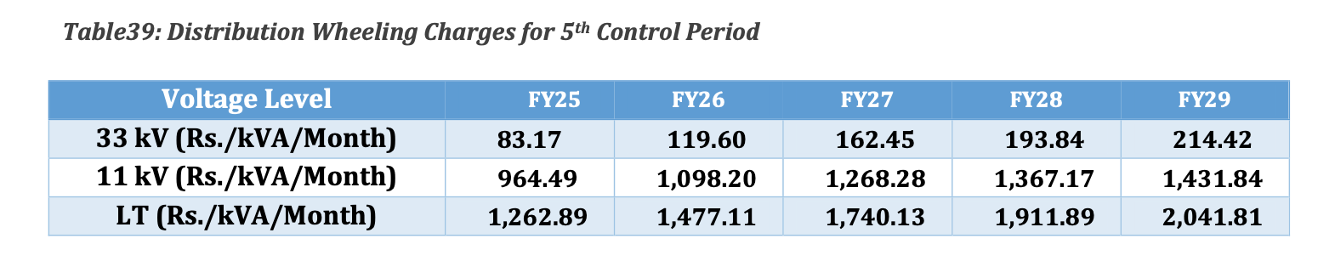

Kindly see the Distribution tariff of Rs. 964.49/kVA/Month proposed for 11 kV which is more than Rs 475/kVA/Month. The proposed tariff is totally wrong and cannot be justified. No 11 kV OA consumer can afford this tariff.

For example, consider a case of conventional Generator supplying power to consumers at all the three voltages i.e., 132 kV, 33 kV, 11 kV & LT consumers.
The PLF for conventional power is 100%. One kW purchase from conventional power would be around 720 units in a month.

The corresponding per unit costs is as shown below:
The Transmission wheeling cost at 132 kV = 221.17/720 = Rs. 0.31/kWh.
The Distribution wheeling cost at 33 kV= 83.17/720 = Rs.0.12/kWh.
The Distribution wheeling cost at 11 kV = 964.49/720 = Rs. 1.34/kWh.
The Distribution wheeling cost at LT Voltage = 1262.89/720 = Rs. 1.754/kWh.

Consider a case of Mini Hydel Generator supplying power to consumers at all the three voltages i.e., 132 kV, 33 kV, 11 kV and LT consumers.
The PLF of Mini Hydel Power plant is around 20%. One kW SPP can pump around 144 units in a month.

The Transmission wheeling cost at 132 kV = 221.17/144 = 1.54/kWh.
The Distribution wheeling cost at 33 kV = 83.17/144 = 0.58/kWh.
The Distribution wheeling cost at 11 kV = 964.49/144 = 6.70/kWh.
The Distribution wheeling cost at LT Voltage = 1262.89/144 = Rs.8.77/kWh.

Voltage | RST (Tariff) .  Rs /kWh. | Proposed Tr/Wheeling tariff for Fy 2025 - Rs/kW/month. | Proposed Transmission/Wheeling Tariff in Rs/kWh. | Per unit wheeling cost for Solar Power Plant. (Rs/kWh). | Generator Maximum selling price Rs./unit.
(1) | (2) | (3) | (4) | (5) | (6)=(2)-(5)
132 kV | 5.4 | 221.17 | 0.31 | 1.54 | 3.86
33 kV | 5.85 | 83.17 | 0.12 | 0.58 | 5.27
*11 kV | 6.3 | 964.49 | 1.34 | 6.70 | -0.40
LT | 6.7 | 1262.89 | 1.75 | 8.77 | -2.07

Voltage | Conventional Power with PLF of 100%. Rs /kWh  (Wheeling cost) | NCE Power with PLF of 20%. Rs/kWh  (Wheeling cost) | Difference (Additional cost to NCE)
132 kV | 0.31 | 1.54 | 1.23
33 kV | 0.12 | 0.58 | 0.46
11 kV | 1.34 | 6.70 | 5.36
LT | 1.754 | 8.77 | 7.02

For a 11 kV Consumer, the generator has to sell power @ Rs (-) 0.40 per unit with reference to TO rate which is practically not possible.

This indicates that the methodology adopted by the Hon’ble Commission may not be correct approach. In this regard, we submit to the Hon’ble Commission to take corrective action and determine reasonable energy based Transmission and wheeling tariffs.

10). The proposed Distribution tariff of 964.19 is 203 % of Demand charge of Rs 475/kVA/Month, which is very high. We are not able to comprehend the reasons for fixation of higher Distribution wheeling tariff while maintaining the Retail Power Supply tariffs intact. If the present tariff is built into the RST, RST perhaps would definitely go up. Or the reason behind the hiking the Distribution business Tariff alone may be to discourage Open Access consumers, which is against the spirit of the Electricity Act, 2003 and may not yield the anticipated competition, efficiency and addition of new generation.
11) Drawback in the present method:
(i) Due to apportioning of 33 kV network cost to 11 kV and LT network based on the asset base utilisation by the respective voltage level consumers, the wheeling tariff for 33 kV consumers is relatively less when compared to 11 kV tariff and EHT transmission tariff. The same can be observed from the following tables.

Table-1 MYT Tariffs for 2014 -15 to 2018-19
Voltage | 2014-15 | 2015-16 | 2016-17 | 2017-18 | 2018-19
EHT tariff Rs./kW/month | 65.30 | 71.66 | 91.36 | 95.37 | 94.44
33 kV Rs./kW/month  (EPDCL tariff) | 13.46 | 10.98 | 11.38 | 11.80 | 12.22
11 kV Rs/kW/month (EPDCL Tariff) | 240.15 | 232.39 | 247.55 | 262.96 | 279.50

Note 1: Please note that the 11 kV EPDCL tariff varies from Rs 240 to Rs. 279 for 2014 to 2019. The 11 kV wheeling tariff is almost 50 % of Demand charge of 475/kVA/Month. This indicates that there is some error in computing these charges.

Table-2 MYT Tariffs for 2014 -15 to 2018-19
Voltage | 2014-15 | 2015-16 | 2016-17 | 2017-18 | 2018-19
EHT tariff Rs./kW/month | 65.30 | 71.66 | 91.36 | 95.37 | 94.44
33 kV Rs./kW/month  (SPDCL tariff) | 7.66 | 15.51 | 15.39 | 15.11 | 15.17
11 kV Rs/kW/month  (SPDCL tariff) | 164.61 | 220.82 | 227.14 | 232.16 | 240.68
Note: 2: Please note that the 11 kV SPDCL tariff varies from Rs 164 to Rs. 240 for 2014 to 2019. The 11 kV wheeling tariff for 2018-19 is almost 50 % of Demand charge of 475/kVA/Month. This indicates that there is some error in computing these charges. Observe the huge variation; the APSPDCL tariff begins at 164 for year 2014-15 against APEPDCL tariff of Rs. 240/kW/Month.

Table-3 MYT Tariffs for 2019 - 20 to 2023-24 MYT
v) Voltage | 2019-20 | 2020-21 | 2021-22 | 2022-23 | 2023-24
EHT tariff Rs/kW/month | 119.28 | 138.88 | 154.54 | 173.79 | 188.38
33 kV Rs./kW/month  (EPDCL tariff) | 45.24 | 48.38 | 54.73 | 59.51 | 61.92
11 kV Rs/kW/month  (EPDCL Tariff) | 349.71 | 375.94 | 427.50 | 467.43 | 439.07

Note 3: Please note that the 11 kV EPDCL tariff varies from Rs 349 to Rs. 439 for 2019 to 2023. The 11 kV wheeling tariff for 2019-20 is almost 73 % of Demand charge of 475/kVA/Month. This indicates that there is some error in computing these charges. Correspondingly the 11 kV retail tariff should reflect this cost impact. But it is not so.

Table-4 MYT Tariffs for 2019 - 20 to 2023-24 MYT
vi) Voltage | 2019-20 | 2020-21 | 2021-22 | 2022-23 | 2023-24
EHT tariff Rs/kW/month | 119.28 | 138.88 | 154.54 | 173.79 | 188.38
33 kV Rs./kW/month  (SPDCL tariff) | 61.16 | 64.11 | 69.34 | 75.44 | 79.48
11 kV Rs/kW/month  (SPDCL tariff) | 432.38 | 447.58 | 478.38 | 514.76 | 536.83
Note 4: Please note that the 11 kV APSPDCL tariff varies from Rs 432 to Rs. 536 for 2019 to 2023. The 11 kV wheeling tariff for 2019-20 is almost 90% of Demand charge of 475/kVA/Month. This indicates that there is some error in computing these charges. Correspondingly the 11 kV retail tariff should reflect this cost impact. But it is not so.
From table (3) and (4), kindly observe the variation in wheeling tariffs in between APSPDCL and APEPDCL.

12). From the above tables, it can be observed that there is abnormal variation in EHT, 33 kV and 11 kV tariffs. The reasons for the abnormal variation are mentioned below:
(a) O&M Expense allocation
Please See Para 2.3 of Page 27 of ARR of APSPDCL
1) Employee Expenses(EE) and Administrative & General Expenses (A&G)
Employee expenses and A&G expenses have been apportioned as per the distribution of No. of Consumers, Number of DTRs, Length of lines and Number of SS.
a) Licensee projected the voltage wise No. of Consumers, Number of DTRs, Lengths of lines and Number of SS and then observed voltage-wise percentage of each of these parameters.
b) As per employee expenses and A&G expenses projections done in section 1.6, licensee allocated these expense into SS, line length, DTR and consumer in the ratio of 49% : 21% : 10% : 20%.
c) Expense allocation of SS, line length, DTR and consumers are then apportioned to LT, 11kV and 33kV voltage level as per the observed percentages of these parameters.
d) The allocated ratios mentioned in para (b) are assumed percentages and erratic. There is no basis for these numbers. The details of observed percentages mentioned in para (c) are not mentioned here.
e). Grossing up of loads to higher voltages. This is explained in the following paras.

Note1: One of the main reasons for the increase in 11 kV wheeling tariff is that the 11 kV network cost increased due to implementation of HVDS network for Agl consumers. While implementing HVDS scheme, LT network is converted into 11 kV HT network. The cost of Service of Ag1 consumers is being paid by CoAP in the form of subsidy. No agriculture consumer avails Open Access and hence, the 11 kV HVDS network cost need to be excluded to arrive at 11 kV wheeling tariff if voltage wise wheeling tariffs are to be determined.
Note 2: All the DISCOMs have considered and assumed the same percentages mentioned in the Para 13(1)(b). Practically it is not possible to have same line lengths, SS and DTRs etc. Kindly consider the assumptions made and a corrective action may please be taken.
13. Methodology followed by the Hon’ble Commission - Grossing up of Demand with losses:

To arrive at 33 kV, 11 kV and LT demand, the DISCOMs have adopted the method as mentioned below which is extracted from MYT Distribution tariff proposals for the 5th Control period:

The Demand at 33 kV contributed from all voltages was computed by adding up the following:
- Grossed up 33 kV Contracted Demand with 33 kV losses;
- Grossed up 11 kV Contracted Demand with 11 kV losses and further by 33 kV losses;
- Coincident Demand of LT was grossed up with LT, 11kV and 33 kV losses.
The Demand at 11 kV contributed from all the voltages was computed by adding the following:
- Grossed up 11 kV Contracted Demand with 11 kV losses.
- Coincident Demand of LT was grossed up with LT and 11kV losses.
The Demand at LT is the estimated Coincident demand of LT plus grossed up with LT losses.
Note: Kindly refer page 24, Table 27 and Page 25, Table 28 of MYT Proposals of APSPDCL. Our observation is that 33 kV Demand and LT Demand were interchanged in Table 28. The 33 kV Demand 707.13/0.75 = 942 MW which is shown in LT of Table 28. The LT Demand of 2165 is shown against 33 kV in Table 28. May please be checked and can take corrective action.
Technically, grossing up of 33 kV CMDs with 33 kV losses and 11 kV CMDs with 11 kV losses and further by 33 kV losses may not be correct. There would be a diversity factor for 11 kV demands and for 33 kV demands as all consumers demands may not occur simultaneously. Grossing up can be done in case of Coincident Demand is considered as is done in case of LT.

14). Approach followed for determination of wheeling tariff:
Assuming the determination of voltage wise tariff is in right direction, to arrive at Net ARR, the Commission deducted the Wheeling Revenue from OA Consumers. From the wheeling tariff, OA revenue is recovered from OA consumers. The total wheeling ARR includes OA revenue and revenue form native DISCOM consumers. The Wheeling tariff is embedded in RST and hence deducting OA revenue from Wheeling ARR is not correct. Deducting the estimated Wheeling Revenue from Gross Revenue may not be correct approach since the aim of this exercise is to determine Wheeling tariff for OA Consumers. The DISCOMs are also such LTOA Consumers of APTRANSCO.
The ARR of wheeling business for FY 2024-25, first the Gross ARR of Rs. 4,664 crs arrived. Then net ARR (Rs. 4227 crs) is arrived by deducting wheeling revenue of Rs. 437 crs. The whole purpose of this exercise is to determine wheeling tariffs for all network users viz., DISCOM consumers and OA consumers. DISCOMs pay their Transmission Charges to APTRANSCO on their contracted demand through recovery of wheeling tariff determined by the Commission. In fact, there is no point in arriving at net revenue by deducting wheeling Revenue (If any non-tariff income exists, the same can be deducted from Gross Revenue). The relevant table extracted from the Distribution business ARR is shown below.
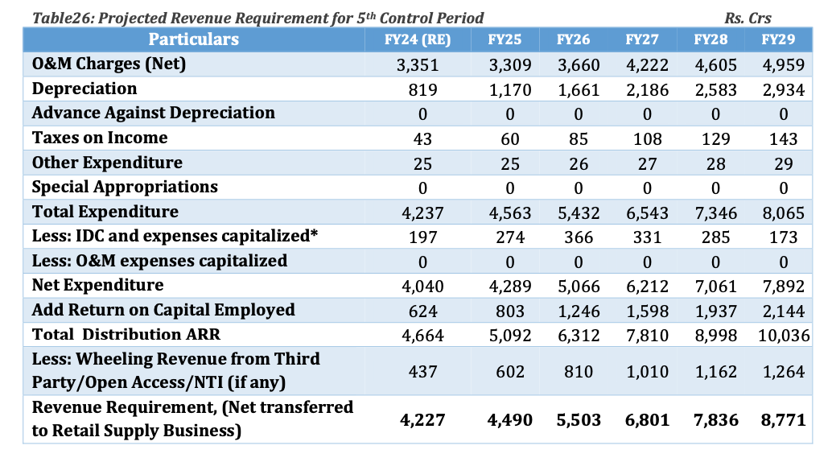
15). What should be the philosophy to determine wheeling tariff?
The Hon’ble Commission may please examine the methodology followed while determining Development Charges and treatment of losses in determining the Retail Supply Tariffs (RST). The Hon’ble Commission has issued a Tariff Philosophy wherein a concept called rationalisation of tariffs was published during 1999-2000. The concept is nothing but balancing the tariffs in between affordability (paying capacity) to pay the tariff determined by the Commission and Cost of Service of power.
The Commission adopted the concept of rationalisation of tariffs while fixing Development Charges and treatment of losses while determining RST. The Commission also followed tariff philosophy while recovering the Transmission Cost, SLDC Cost, Distribution Cost, PGCL Expenses, and ULDC Charges etc,. The same is mentioned in Para 3 above.
16). Treatment of losses: For example, the total system losses are around 13%. EHT losses, 33 kV, 11 kV and LT losses are around 2.85%, 3%, 3% and 4% respectively. While fixing the tariff, the Hon’ble Commission did not allocate EHT loss and 33 kV loss to EHT and 33 kV consumers respectively. The Hon’ble Commission arrived average system losses and determined the tariff.
17). Fixation of Development Charges: While determining development charges, the Hon’ble Commission adopted shallow method, i.e., did not consider pro-rata EHT network cost based on asset usage to arrive at 33 kV network cost. Similarly, 33 kV network cost is not included in the 11 kV network cost based on asset utilisation and the same approach is being followed to fix LT development charge.
18) The power system is designed in an efficient, economic and for optimum utilization of network assets. Based on the power capacity to be transmitted, the transmission system and sub transmission system is designed. The assumption of existence of 33 kV network is to meet the demand of 11 kV network consumers and LT consumers may not be correct. Similarly, the assumption of networks of 33 kV and 11 kV exist to meet the demand of LT consumers is also not correct. They are interdependent. Without LT & 11 kV consumers, the 33 kV consumers cannot survive and vice versa is also true.
19. The reasons for justification of Tariff Philosophy
- EHT network is not established for the sake of 33 kV, 11 kV or LT Consumers. It is the system design criteria.
- To have economical operation, higher efficiency and based on the line lengths, we choose higher voltages. For example, as per CEA Planning criteria, above 160 MW, we go to 220 kV. Above 300 MW, we go to 400 kV. Losses and system stability also plays important role while choosing the transmission voltage level.
- EHT system alone cannot sustain without the presence of 33 kV, 11 kV or LT consumers.
- All consumers, right from LT domestic/ Agl. consumers to EHT consumers play important role in maintaining the system demand. All consumers are equally important in maintaining the healthy system. As mentioned above, EHT plus 33 kV system cannot sustain in the absence of LT and 11 kV consumers. Similarly, in the absence of 33 kV or EHT consumers, we cannot maintain the stable and healthy power system. The diversity of LT and 11 kV consumers provide demand support to the system and thus enhances revenue and vice- versa is also true.
From the above, it is evident that the system requires all consumers for economical and efficient operation of the power system. Hence, Wheeling tariff Rate can be determined taking the Total ARR of distribution business and dividing the same with the total sales (both DISCOM sales and OA sales and excluding EHT sales).
20). For the reasons mentioned in Para 13 to 20, instead of assuming arbitrary percentages, it is suggested to arrive at wheeling tariff for entire distribution business together and the same is explained hereunder.
WTR = Net ARR/ Wheeled Units (Energy sales of all voltages including Agl sales, OA sales and excluding EHT sales)
Where,
WTR: Wheeling Tariff Rate in Rs./kWh
Net ARR: Net ARR (Gross ARR – Other income, like non tariff income etc.,).

21). Methods adopted by MERC and KERC
MERC has fixed wheeling charges on per unit basis i.e, Rs./kWh or Rs./kVAh. To arrive at a wheeling charge on per unit basis the ARR related to HT (Exclusive of EHT) is divided by HT sales. Here, HT means 33 kV, 22 kV and 11 kV. The LT ARR is divided by LT sales and thus fixed the wheeling charges for HT and LT categories. The relevant MERC MYT order for FY2020-21 to FY2024-25 can be accessed from MERC website.
KERC also has adopted a similar procedure like the MERC method. It appears that the methods adopted by MERC and KERC may also be examined.

22). The Wheeling tariffs proposed by DISCOM are very high compared to Demand charges of Rs. 475/kVA/Month and it appears that there is some error in the methodology followed by the DISCOMs. The Hon’ble Commission may also need to follow Tariff Philosophy mentioned in Para 16 to 19 while determining the Wheeling charges.
Allocation of network costs to 33 kV, 11 kV and LT system based on the Demand consumption may not be right approach and the same is explained in Para 17, 18 and 19. For the reasons mentioned above, we submit to the Hon’ble Commission to do away with the methodology of allocating network costs to 33 kV, 11 kV and LT based on respective demand consumption.
In view of the above, we further submit to the Hon’ble Commission to determine nominal energy-based wheeling charges for both Transmission and Distribution networks by dividing the Capacity based tariff with 720, 720 being the number of hours in a month.

With regards,

For Small Hydro Power Developers Association
Sd/-
Secretary

